**Cheque Pay – Cheque Printing Solution**

**Version 1.1.0-fr001** 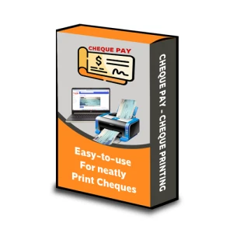

**Table of Contents**

Table of Contents

Overview 2

Registration 5

Login 5

Buying Product 6

Purchase 6

Accessing Application 8

## Overview

**Cheque Pay - Cheque Printing Solution**

The **Cheque Pay** application is a comprehensive cheque printing solution tailored for businesses, accountants, and individuals who regularly issue bank cheques. With increasing digitalization, manual cheque writing can be time-consuming and prone to errors. Cheque Pay resolves these challenges by offering a user-friendly, precise, and customizable platform that ensures professional cheque printing with minimal effort.

Designed to support multiple bank formats and institutions, this solution empowers users to print cheques that conform to bank-specific layouts. Whether the user is printing a single cheque or handling bulk cheque issuance, Cheque Pay streamlines the process with precision and flexibility.

**Key Features:**

* **Customizable Templates**: Upload scanned images of your bank's cheque leaves and define the positions for fields like Date, Payee, Amount in Numbers, Amount in Words, and Signature using a drag-and-drop interface.
* **Multi-Company Management**: Handle cheque issuance for multiple companies under a single user account. Each company can maintain its own templates, bank accounts, and payee information.
* **Multi-Currency Support**: Supports printing in different global currencies (e.g., INR, USD, EUR), including localized amount-in-words generation.
* **Preview & Print**: Users can preview cheques with actual data before printing, reducing errors and avoiding cheque wastage.
* **Cloud or On-Premise Deployment**: Flexibility to deploy Cheque Pay on a local server or cloud, based on organizational requirements.
* **Security & Licensing**: Licensing features are built-in to control usage, ensuring that only authorized users and devices can access company data.

**Customization:**

Cheque Pay allows advanced customization of fonts, sizes, styles (bold, italic), and positioning for each text field. These settings can be saved per template, offering a high degree of flexibility for institutions with unique formatting standards.

Additionally, users can add background logos, watermark overlays, or include authorized signatory lines where applicable. The application ensures that each cheque appears uniform, professional, and aligned to the bank's clearance standards.

**Use Cases:**

* **Small and Medium Enterprises (SMEs)**: Manage multiple accounts, banks, and payees without depending on pre-printed cheques.
* **Chartered Accountants & Finance Professionals**: Print cheques for multiple clients while maintaining a record of issued cheques.
* **Personal Finance Management**: Individuals can track and print cheques with ease, avoiding handwriting errors and maintaining clarity.

**Technical Notes:**

* Built using Django (Python) on the backend for high reliability and security.
* JavaScript-driven front-end for dynamic UI interactions, including drag-and-drop text placement.
* MS SQL Server or SQLite for flexible database options depending on deployment scale.
* Compatible with standard A4/cheque printers and supports margin calibration for precise output.

**Advantages of Using Cheque Pay:**

* Reduces cheque handling time by automating formatting and positioning.
* Minimizes human errors such as spelling mistakes, misplaced text, or wrong amounts.
* Centralizes cheque records for better auditing, traceability, and reporting.
* Ensures professional output, enhancing brand credibility and presentation.
* Easy-to-use interface requiring no technical background or design skills.

## Registration

To access the application user firstly needs to register on the official site of the company i.e. [PEGASUS](https://www.pegasustech.net/index.php?route=account/register) (click on the link to go to registration page).

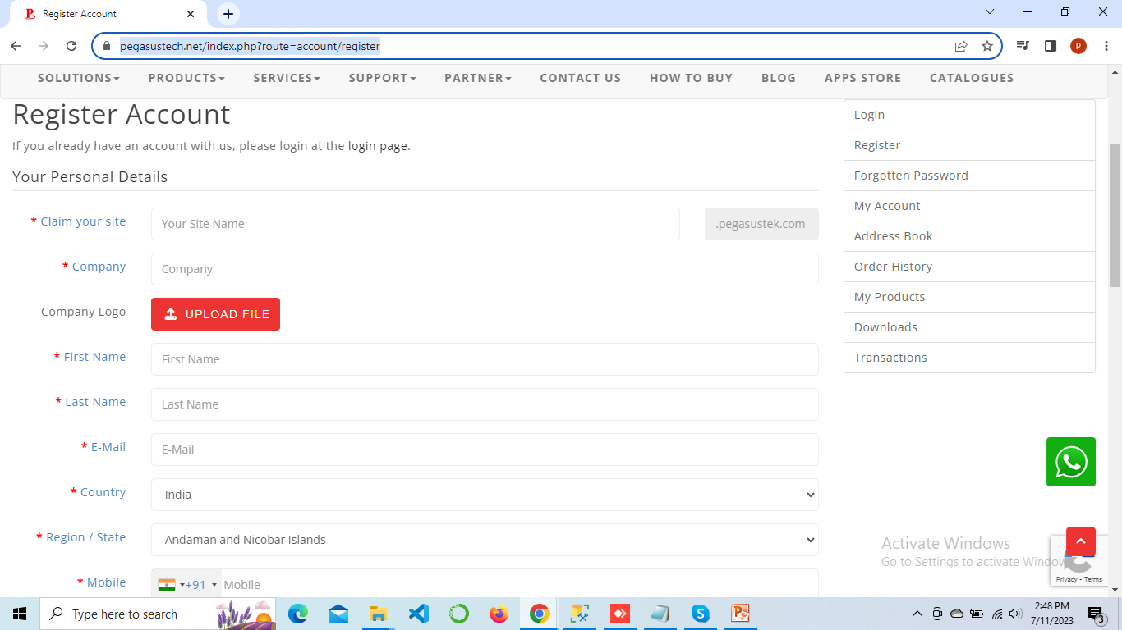

## Login

After registering go to login page and login with the details you have registered with, like email and password. User gets the login info via registered mail too.

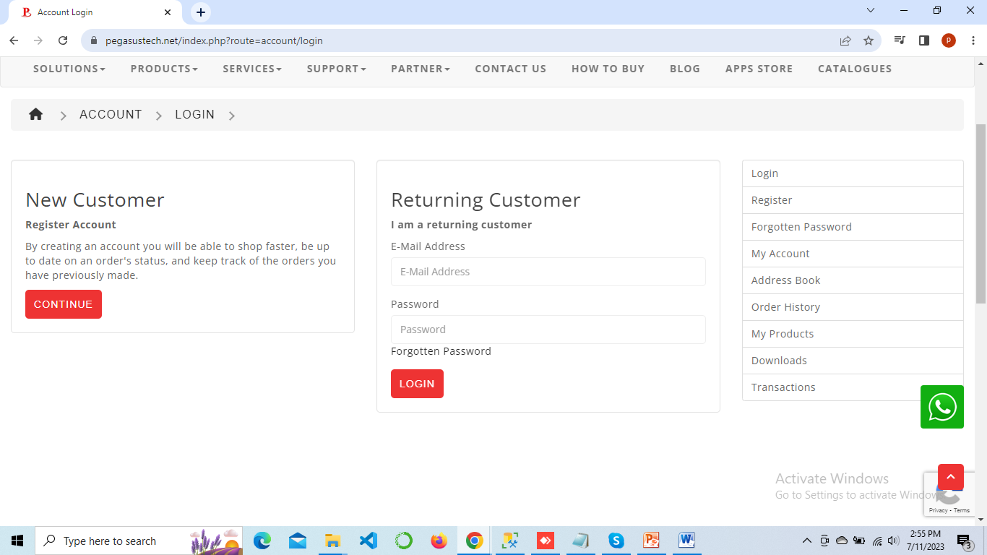

## Buying Product

After login user should go to Apps Store**>** Android Cloud Attendance System and select Buy to purchase the application or take a trial.

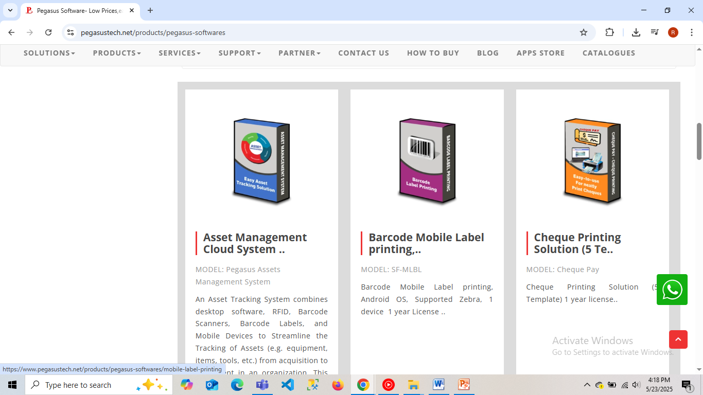

## Purchase

Moving next, user needs to click on the suitable option to carry on further.

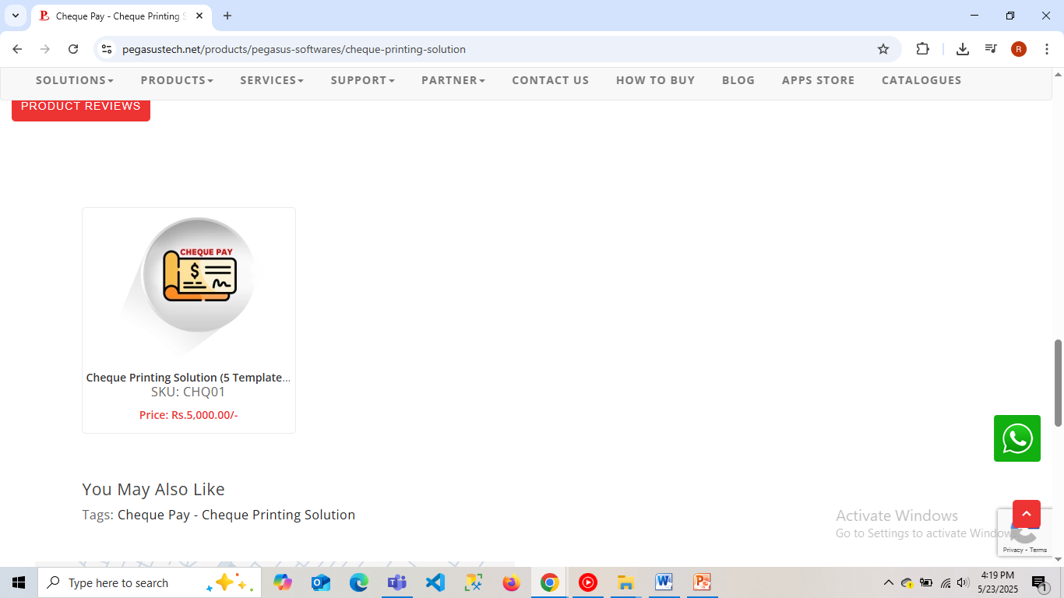

And select the suitable option to purchase the product or take a trial as suited.

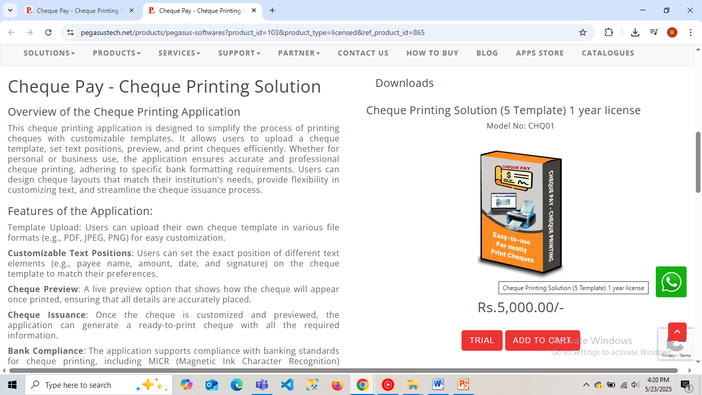

After the purchase, user will get the mail with the details of purchase and a link to access the product.

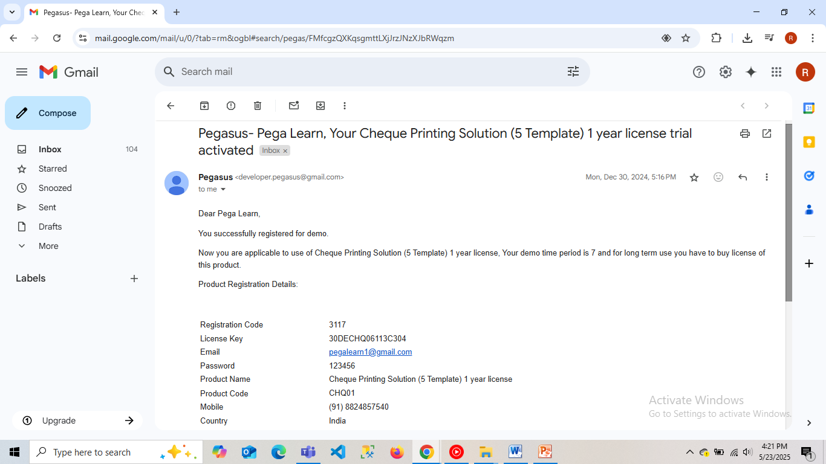

## Accessing Application

* After clicking on the link provided in the mail, user will get to the apps store where the licensed product will be shown and the product link available to access.

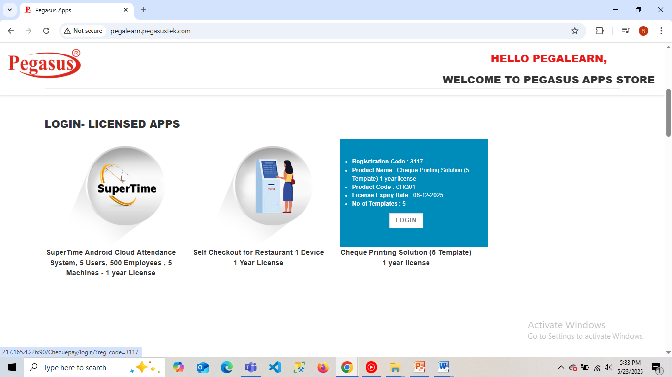

Click on the login button to access the product, which will lead you to a login screen, fill in the data made available to user in the email as mentioned. Where **Registration Code** will be **Registration Code,** **Username** will be the **Email**, and **Password** will be the **Password** provide to the user via email on the registered email.

* After going through the link via browser you can see the application running, click on the login to go to the login page.

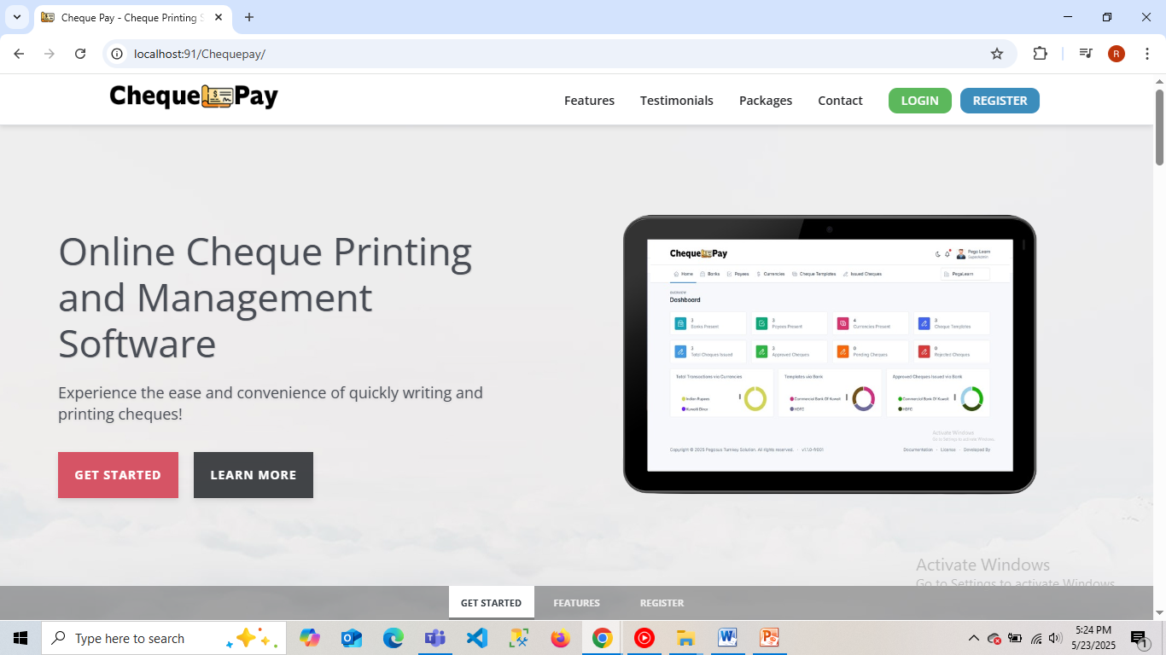

* Work through the application as you wish.

